

MINISTRY OF EDUCATION AND RESEARCH OF THE REPUBLIC OF MOLDOVA
Technical University of Moldova
Faculty of Computers, Informatics and Microelectronics Department of Software Engineering and Automation

Report
Laboratory Work No. 3
Cryptography and Security
Topic: Polyalphabetic Ciphers – the Vigenère Cipher (Task 3.2)

Realized by:
Cereteu Maxim, FAF -243

Checked by:Maia Zaica
______________________

Chişinău – 2026

Contents

1 Purpose of the Laboratory Work 3
2 Task of the Laboratory Work 3
3 Theoretical Considerations 3
3.1 Polyalphabetic substitution ciphers 3
3.2 The Vigenère cipher 3
3.3 The Romanian alphabet with 31 letters 4
4 Practical Implementation 4
4.1 Structure of the program 4
4.2 Encryption of the example from the guide 5
4.3 Decryption of the example 6
4.4 A Romanian message with diacritics 6
4.5 Validation of the input 7
4.6 Program listing 8
5 Conclusions 10
6 Bibliography 10

Purpose of the Laboratory Work
To study the polyalphabetic substitution ciphers, which hide the frequency distribution of the plaintext by encrypting the same letter in different ways, and to implement the Vigenère cipher for messages written in the Romanian language, using an alphabet of 31 letters coded with the numbers 0, 1, …, 30.

Task of the Laboratory Work
Task 3.2. Implement the Vigenère algorithm in a programming language for messages in the Romanian language (31 letters), coded with the numbers 0, 1, … 30. The characters of the text may only be between ‘A’ and ‘Z’ and between ‘a’ and ‘z’; no other values are allowed. If the user enters other values, the correct range of characters has to be suggested. The length of the key must not be smaller than 7. Encryption and decryption are done according to the formulas of the mathematical model of the cipher. In the message the spaces are removed first and then all the letters are turned into capitals. The user chooses the operation – encryption or decryption – enters the key and the message or the cryptogram, and obtains the cryptogram or the decrypted message.
According to the laboratory guide, students with an odd number in the group register solve Task 3.1 (Playfair) and those with an even number solve Task 3.2. My number in the register is 4, so the task solved in this work is Task 3.2 – the Vigenère cipher. The program was written in Python 3.

Theoretical Considerations

Polyalphabetic substitution ciphers
The weakness of the monoalphabetic ciphers, studied in the previous laboratory work, is that every letter is always replaced by the same letter, so the frequency distribution of the ciphertext repeats the distribution of the language. A cipher is stronger when its distribution is as flat as possible and gives no information to the cryptanalyst. One way to obtain this is to combine high frequencies with low ones: if a frequent letter is encrypted sometimes as one symbol and sometimes as another, and a rare letter is mixed into the same symbols, the resulting frequencies become more uniform.
In a polyalphabetic cipher the substitution of a character changes along the text, depending on its position or on other parameters, so several translation alphabets are used in turn. The number of possible keys becomes much larger than for a single alphabet. The first polyalphabetic system is usually attributed to Leon Battista Alberti, and simple polyalphabetic schemes are still used in some parts of modern applications.

The Vigenère cipher
The method known as the Vigenère cipher was first described by Giovan Battista Bellaso in 1553 (“La cifra del. Sig. Giovan Battista Bellaso”) and was later wrongly attributed to Blaise de Vigenère. It uses the same operation as the Caesar cipher – a shift of the letters – but instead of a single shift it uses several shifts k₁, k₂, …, kₙ, given by the letters of the key. The key is repeated over the whole message, so the i-th letter is shifted by the letter of the key that stands above it. For an alphabet of N letters:
encryption: cᵢ = (mᵢ + kᵢ) mod N, decryption: mᵢ = (cᵢ – kᵢ) mod N.
In the guide N = 26 (the English alphabet). In this work N = 31 because the Romanian alphabet has 31 letters. The multiple shift gives two kinds of protection: the attacker does not know the length of the key and the number of keys grows exponentially with this length. With a 31-letter alphabet and the minimal key length of 7 letters required by the task an exhaustive search would have to try 31⁷ = 27 512 614 111 keys (for comparison 26⁷ = 8 031 810 176).
Instead of the formulas, the Tabula Recta can also be used: a 26 × 26 (here it would be 31 × 31) table in which every row is the alphabet shifted by one more position; the ciphertext letter is found at the intersection of the row of the key letter and the column of the message letter. The program uses the formulas directly, which is equivalent.

The Romanian alphabet with 31 letters
The Romanian alphabet contains the 26 Latin letters and five letters with diacritics: Ă, Â, Î, Ș and Ț. The letters are coded with the numbers 0…30 in alphabetical order, each diacritic letter being placed right after its base letter (Table 1). Because of these extra letters, the codes of most letters differ from the English ones: for example S has the code 21 here, and 18 in the 26-letter alphabet.
Letter | A | Ă | Â | B | C | D | E | F | G | H | I | Î | J | K | L | M
Code | 0 | 1 | 2 | 3 | 4 | 5 | 6 | 7 | 8 | 9 | 10 | 11 | 12 | 13 | 14 | 15
Letter | N | O | P | Q | R | S | Ș | T | Ț | U | V | W | X | Y | Z
Code | 16 | 17 | 18 | 19 | 20 | 21 | 22 | 23 | 24 | 25 | 26 | 27 | 28 | 29 | 30
Table 1. Coding of the 31 letters of the Romanian alphabet

Practical Implementation

Structure of the program
The program is a single Python file, vigenere.py (the full listing is given at the end of the report). It works in the console and offers a menu with the operations: 1 – encryption, 2 – decryption, 3 – display of the alphabet with its codes and 0 – exit. Its main parts are:
– ALPHABET – the string “AĂÂBCDEFGHIÎJKLMNOPQRSȘTȚUVWXYZ”; the position of a letter in it is its code, and the dictionary CODE gives the code of each letter directly;
– prepare() – removes all the spaces, converts the text to capitals and checks that only the 31 letters are left; the cedilla forms Ş and Ţ, which are often typed instead of Ș and Ț, are treated as the same letters;
– prepare_key() – applies the same checks to the key and also requires at least 7 letters;
– vigenere(text, key, sign) – the cipher itself: for every position i it computes (code(text[i]) + sign · code(key[i mod len(key)])) mod 31, with sign = +1 for encryption and –1 for decryption, exactly as in the mathematical model;
– table() – prints the same step-by-step table as in the example from the guide (letters, their codes, the sum or difference modulo 31 and the result); it is shown for short texts (up to 24 letters);
– ask() – reads a value from the user until it is valid; after every wrong value the error and the correct range of characters are displayed, and the user can type the value again.
Figure 1 shows the program started and option 3, which prints the coding of the alphabet used in all the computations (the same as in Table 1).
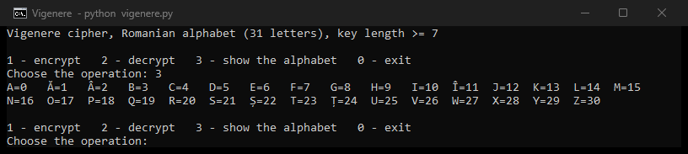
Figure 1. The menu of the program and the coding of the 31-letter alphabet (option 3)

Encryption of the example from the guide
To check the program, the message from the guide, “Per aspera ad astra”, was encrypted. The guide uses the key SUPER, but the task requires at least 7 letters, so the key SUPERSTAR (9 letters) was used. After removing the spaces and converting to capitals the message becomes PERASPERAADASTRA (16 letters). Table 2 shows the computation done by hand with the codes from Table 1.
Plaintext M | P | E | R | A | S | P | E | R | A | A | D | A | S | T | R | A
Key K | S | U | P | E | R | S | T | A | R | S | U | P | E | R | S | T
Plaintext code | 18 | 6 | 20 | 0 | 21 | 18 | 6 | 20 | 0 | 0 | 5 | 0 | 21 | 23 | 20 | 0
Key code | 21 | 25 | 18 | 6 | 20 | 21 | 23 | 0 | 20 | 21 | 25 | 18 | 6 | 20 | 21 | 23
M+K (mod 31) | 8 | 0 | 7 | 6 | 10 | 8 | 29 | 20 | 20 | 21 | 30 | 18 | 27 | 12 | 10 | 23
Ciphertext C | G | A | F | E | I | G | Y | R | R | S | Z | P | W | J | I | T
Table 2. Encryption of the message “PERASPERAADASTRA” with the key SUPERSTAR
For example, the first letter P (18) with the key letter S (21) gives (18 + 21) mod 31 = 8, that is G, and the fourth letter A (0) with the key letter E (6) gives 6, that is E. The obtained cryptogram is C = GAFEIGYRRSZPWJIT. It differs from the cryptogram in the guide (HYGEJHYGERVUHXIS) because both the alphabet (31 letters instead of 26) and the key are different. Figure 2 shows that the program gives the same result and the same intermediate values as Table 2.
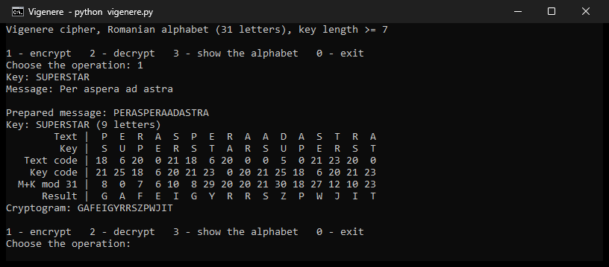
Figure 2. Encryption of “Per aspera ad astra” with the key SUPERSTAR
Here the polyalphabetic nature of the cipher is clearly seen: the group “PERA” appears twice in the message, but it is encrypted once as GAFE and once as GYRR, and the five letters A of the message are encrypted as E, R, S, P, T. A frequency analysis of single letters, as in the previous laboratory work, would not work here.

Decryption of the example
For decryption the reverse formula mᵢ = (cᵢ – kᵢ) mod 31 is applied with the same key (Table 3). When the difference is negative, 31 is added: for the first letter, G (8) – S (21) = –13 ≡ 18 (mod 31), which is P.
Ciphertext C | G | A | F | E | I | G | Y | R | R | S | Z | P | W | J | I | T
Key K | S | U | P | E | R | S | T | A | R | S | U | P | E | R | S | T
Ciphertext code | 8 | 0 | 7 | 6 | 10 | 8 | 29 | 20 | 20 | 21 | 30 | 18 | 27 | 12 | 10 | 23
Key code | 21 | 25 | 18 | 6 | 20 | 21 | 23 | 0 | 20 | 21 | 25 | 18 | 6 | 20 | 21 | 23
C–K (mod 31) | 18 | 6 | 20 | 0 | 21 | 18 | 6 | 20 | 0 | 0 | 5 | 0 | 21 | 23 | 20 | 0
Plaintext M | P | E | R | A | S | P | E | R | A | A | D | A | S | T | R | A
Table 3. Decryption of the cryptogram “GAFEIGYRRSZPWJIT” with the key SUPERSTAR
The decrypted text is M = PERASPERAADASTRA, identical to the prepared message. In Figure 3 the key was intentionally typed in lower case (“superstar”): the program converts it to capitals itself and obtains the same result.
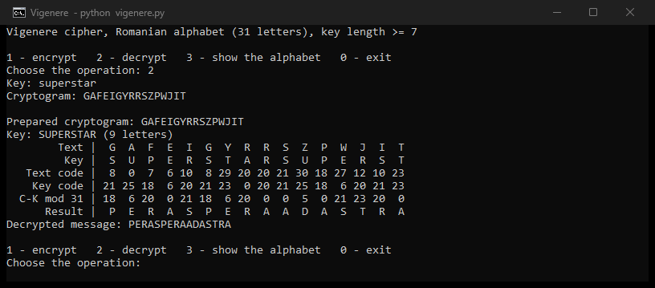
Figure 3. Decryption of the cryptogram GAFEIGYRRSZPWJIT with the key superstar

A Romanian message with diacritics
The second test uses a longer Romanian sentence that contains diacritic letters, “Criptografia este știința scrierii secrete”, and the key “securitate” (10 letters), typed in lower case. The program removes the spaces, converts the letters to capitals (ș → Ș, ț → Ț) and encrypts the 38 letters (Figure 4):
M = CRIPTOGRAFIAESTEȘTIINȚASCRIERIISECRETE
K = SECURITATE
C = UVLJJWARTKAEIMJNLTÂNEZCMȚZÂEJNAWIYHNME
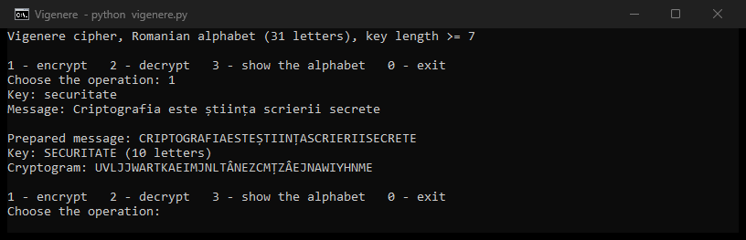
Figure 4. Encryption of a Romanian message with diacritics, key “securitate”
The cryptogram also contains the letters Â and Ț, which do not exist in English, so the full 31-letter alphabet is used. The letter I appears 7 times in the message and is encrypted into 4 different letters (A, L, N, Â). Decrypting the cryptogram with the same key gives back the original message (Figure 5). The last step – inserting the spaces back – is done by the reader: “CRIPTOGRAFIA ESTE ȘTIINȚA SCRIERII SECRETE”.
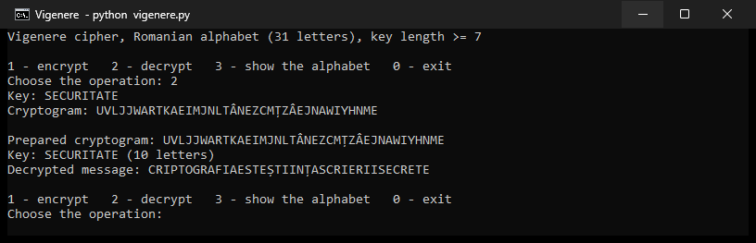
Figure 5. Decryption of the cryptogram with the key SECURITATE

Validation of the input
The task requires that only letters are accepted, that the correct range is suggested in case of an error and that the key has at least 7 letters. Figure 6 shows a session in which several wrong values are entered:
– option “5” – the menu accepts only 1, 2, 3 or 0;
– the key “parola” – it has only 6 letters, at least 7 are required;
– the key “cheie2026” – it contains the digits 0, 2 and 6; the allowed range ‘A’–‘Z’, ‘a’–‘z’ and the Romanian letters Ă Â Î Ș Ț is displayed;
– the message “Bună ziua, lume!” – the comma and the exclamation mark are rejected in the same way.
After each error the program asks for the value again instead of stopping. Finally the key “Securitate” and the message “Bună ziua lume” are accepted: the spaces are removed, the message becomes BUNĂZIUALUME and the cryptogram ȚARVQROAEADJ is obtained. The letter Ă is coded as 1, as expected.
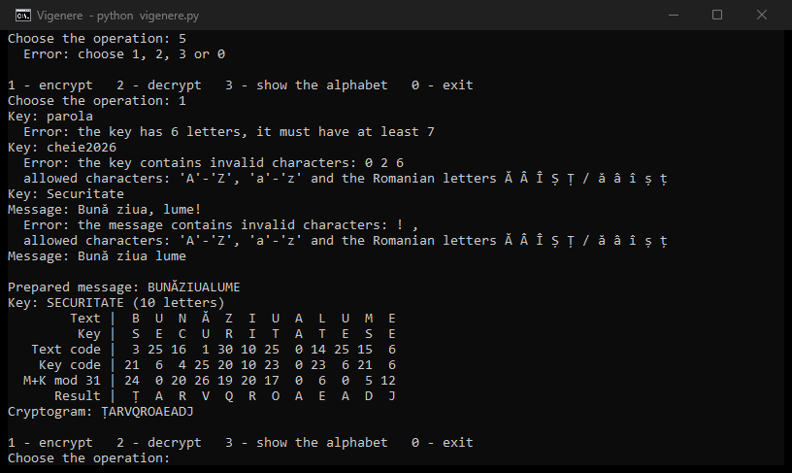
Figure 6. Messages displayed for invalid input and the final correct encryption

Program listing
The full source code of the program vigenere.py:
"""Lab 3 (Cryptography and Security) - Vigenere cipher for Romanian messages (31 letters), Task 3.2.
The letters are coded 0..30 in the order of the Romanian alphabet:
A Ă Â B C D E F G H I Î J K L M N O P Q R S Ș T Ț U V W X Y Z
encryption: c_i = (m_i + k_i) mod 31
decryption: m_i = (c_i - k_i) mod 31
Usage:
python vigenere.py # interactive menu: encrypt / decrypt / show alphabet
"""
import sys
ALPHABET = "AĂÂBCDEFGHIÎJKLMNOPQRSȘTȚUVWXYZ"
N = len(ALPHABET) # 31
CODE = {ch: i for i, ch in enumerate(ALPHABET)}
MIN_KEY = 7
# the cedilla forms (Ş, Ţ) are still common in Romanian texts, they are treated as Ș and Ț
SAME = str.maketrans("ŞşŢţ", "ȘșȚț")
RANGE_HINT = ("allowed characters: 'A'-'Z', 'a'-'z' and the Romanian letters "
"Ă Â Î Ș Ț / ă â î ș ț")
class InputError(ValueError):
pass
def prepare(text, what):
"""Remove the spaces, turn everything to upper case and check that only the 31 letters remain."""
text = text.translate(SAME)
text = "".join(text.split()).upper()
bad = sorted({c for c in text if c not in CODE})
if bad:
raise InputError(f"the {what} contains invalid characters: {' '.join(bad)}\n"
f" {RANGE_HINT}")
if not text:
raise InputError(f"the {what} is empty")
return text
def prepare_key(key):
key = prepare(key, "key")
if len(key) < MIN_KEY:
raise InputError(f"the key has {len(key)} letters, it must have at least {MIN_KEY}")
return key
def vigenere(text, key, sign):
"""sign = +1 encrypts (c = m + k), sign = -1 decrypts (m = c - k), everything mod 31."""
return "".join(ALPHABET[(CODE[c] + sign * CODE[key[i % len(key)]]) % N]
for i, c in enumerate(text))
def encrypt(message, key):
return vigenere(prepare(message, "message"), prepare_key(key), +1)
def decrypt(cryptogram, key):
return vigenere(prepare(cryptogram, "cryptogram"), prepare_key(key), -1)
def table(text, key, sign):
"""The step-by-step table from the lab guide (letters, their codes and the result)."""
key = (key * (len(text) // len(key) + 1))[:len(text)]
res = vigenere(text, key, sign)
op = "M+K" if sign > 0 else "C-K"
rows = [("Text", list(text)), ("Key", list(key)),
("Text code", [CODE[c] for c in text]), ("Key code", [CODE[c] for c in key]),
(f"{op} mod 31", [CODE[c] for c in res]), ("Result", list(res))]
return "\n".join(f"{name:>12} | " + " ".join(f"{v:>2}" for v in vals) for name, vals in rows)
def ask(prompt, check):
"""Read a value until it is valid; the user is told what range of characters is accepted."""
while True:
value = input(prompt)
try:
return check(value)
except InputError as e:
print(f" Error: {e}")
def main():
if hasattr(sys.stdout, "reconfigure"):
sys.stdout.reconfigure(encoding="utf-8")
sys.stdin.reconfigure(encoding="utf-8")
print(f"Vigenere cipher, Romanian alphabet ({N} letters), key length >= {MIN_KEY}")
while True:
print("\n1 - encrypt 2 - decrypt 3 - show the alphabet 0 - exit")
choice = input("Choose the operation: ").strip()
if choice == "0":
break
if choice == "3":
for start in (0, 16):
print(" ".join(f"{c}={i:<2}" for i, c in enumerate(ALPHABET) if start <= i < start + 16))
continue
if choice not in ("1", "2"):
print(" Error: choose 1, 2, 3 or 0")
continue
sign = 1 if choice == "1" else -1
what = "message" if sign > 0 else "cryptogram"
key = ask("Key: ", prepare_key)
text = ask(f"{what.capitalize()}: ", lambda s: prepare(s, what))
print(f"\nPrepared {what}: {text}")
print(f"Key: {key} ({len(key)} letters)")
if len(text) <= 24:
print(table(text, key, sign))
result = vigenere(text, key, sign)
print(("Cryptogram: " if sign > 0 else "Decrypted message: ") + result)
if __name__ == "__main__":
main()

Conclusions
In this laboratory work the Vigenère cipher was implemented in Python for messages in the Romanian language, using an alphabet of 31 letters coded from 0 to 30. Encryption and decryption follow directly the formulas cᵢ = (mᵢ + kᵢ) mod 31 and mᵢ = (cᵢ – kᵢ) mod 31. The results of the program were checked against a computation done by hand (Tables 2 and 3) and every encrypted message was decrypted back to the original text.
The tests show the main property of a polyalphabetic cipher: the same letter of the message is replaced by different letters depending on its position. The repeated group “PERA” gave two different groups, GAFE and GYRR, and the 7 letters I of the Romanian sentence gave 4 different letters. Because of this the frequencies of the cryptogram are flattened and the simple frequency analysis from Laboratory Work No. 2 can no longer be applied.
At the same time, the Vigenère cipher is not secure by modern standards. The key is repeated periodically, so identical groups of the message that are at a distance multiple of the key length produce identical groups in the cryptogram. Knowing this, the length of the key can be found (the Kasiski examination or the index of coincidence), and then the cryptogram splits into several Caesar ciphers, each broken by frequency analysis. This is why a long key – at least 7 letters in this work – and keys that are not ordinary words make the attack harder: for 7 letters there are already 31⁷ ≈ 2,75·10¹⁰ possible keys.
Working with the Romanian alphabet also showed a practical detail: the letters with diacritics must be part of the alphabet and must be recognised in both forms (Ș/Ş, Ț/Ţ), otherwise valid Romanian texts would be rejected or encrypted wrongly.

Bibliography
Laboratory work no. 3 “Polyalphabetic ciphers”, laboratory guide, Cryptography and Security course, Technical University of Moldova.
D. Kahn, The Codebreakers: The Story of Secret Writing. New York: Macmillan, 1967.
Python 3 documentation – Built-in Types, str methods. Available: https://docs.python.org/3/library/stdtypes.html

